# **17. VLANs: PART 2**

## **Basic VLAN Topology from Part 1**

### **Basic VLAN Example:**

## **What About This Network Topology?**

### **Network Example with Two Switches (SW1 and SW2):**

* Notice:
  + **SW1** and **SW2** are connected.
  + The **Engineering VLAN (VLAN 10)** spans two separate locations.

## **TRUNK PORTS**

### **Why Use TRUNK PORTS?**

* In small networks, you can use a separate interface for each VLAN to connect **switches** to **switches** or **switches** to **routers**.
* For larger networks with many VLANs:
  + Using separate interfaces for each VLAN is inefficient and wastes ports.
  + Most routers won’t have enough interfaces for every VLAN.
* **Solution**: Use **TRUNK PORTS** to carry traffic for multiple VLANs over a single interface.

### **Trunk Port Diagram:**

### **How Does a Packet Know Which VLAN to Use Over the TRUNK?**

#### **VLAN TAGGING**

* Switches add **tags** to frames sent over a trunk link.
* This allows the receiving switch to know which VLAN the frame belongs to.

#### **Port Types:**

* **Trunk Port** = “Tagged”
* **Access Port** = “Untagged”

## **VLAN TAGGING PROTOCOLS**

### **Two Main Trunk Protocols:**

1. **ISL (Inter-Switch Link)**
   * Old, Cisco proprietary protocol.
   * Rarely used today.
2. **IEEE 802.1Q** (aka “dot1q”)
   * Industry-standard protocol.
   * Most modern switches support **802.1Q** exclusively.

#### **Ethernet Header with 802.1Q Tag:**

### **802.1Q Tag Structure:**

* **802.1Q Tag** is inserted between the **Source** and **Type/Length** fields in the Ethernet frame.
* The **tag** is 4 bytes (32 bits) long and consists of:
  1. **TPID** (Tag Protocol Identifier):
     + 16 bits (2 bytes).
     + Value: 0x8100 indicates the frame is 802.1Q tagged.
  2. **TCI** (Tag Control Information):
     + Includes three subfields:
       - **PCP (Priority Code Point)**: 3 bits (for Class of Service).
       - **DEI (Drop Eligible Indicator)**: 1 bit.
       - **VID (VLAN ID)**: 12 bits (range 1–4094).

## **VLAN RANGES**

* VLAN IDs: **1 – 4094**
* Reserved VLANs:
  1. VLAN 0 and VLAN 4095 (can’t be used).
* Common VLAN Ranges:
  1. **1 – 1005**: Standard VLANs.
  2. **1006 – 4094**: Extended VLANs.

**NATIVE VLAN**

* **Definition**: VLAN that is **not tagged** on a trunk link.
* By default, VLAN 1 is the **Native VLAN** on Cisco switches.
* Best practice: Use a **dedicated VLAN** for the Native VLAN (e.g., VLAN 99).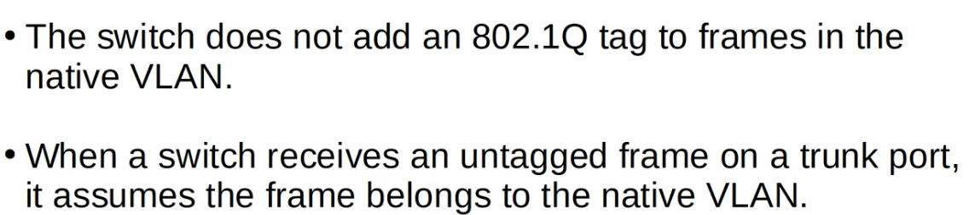
* **Important that the Native VLAN matches between Switches!**

## 

## 

## **TRUNK CONFIGURATION**

### **How to Configure a Trunk Port:**

1. Select the interface to configure.
2. Set the encapsulation type to **802.1Q**:  
   switchport trunk encapsulation dot1q
3. Set the interface mode to **Trunk**:  
   switchport mode trunk
4. Check:  
   do show interfaces trunk

### **Allowing VLANs on a Trunk:**

* Use the following command to allow specific VLANs on a trunk:  
  switchport trunk allowed vlan <vlan_list> 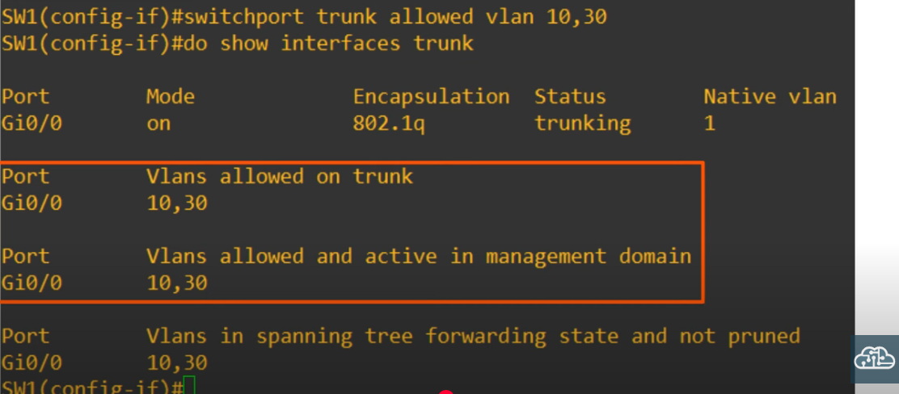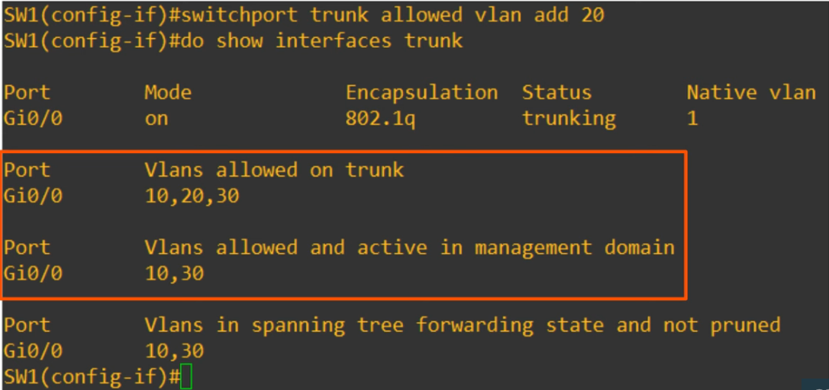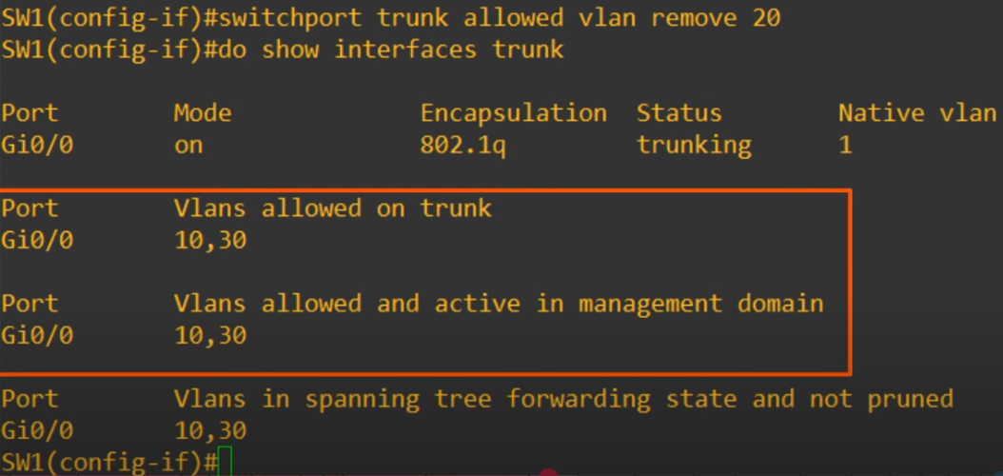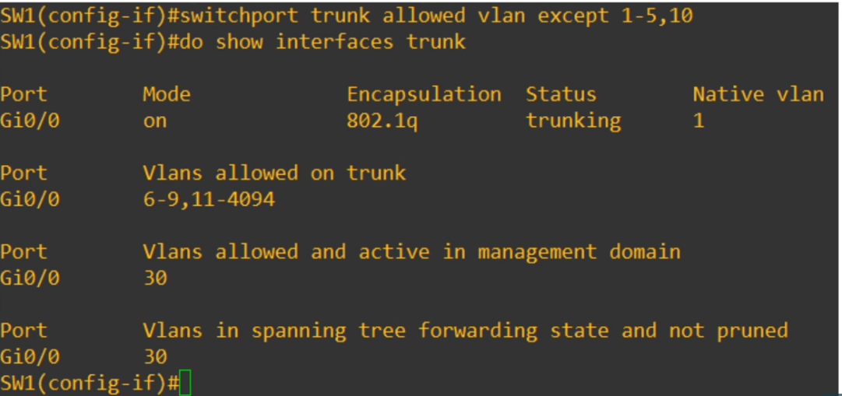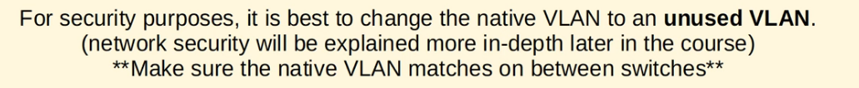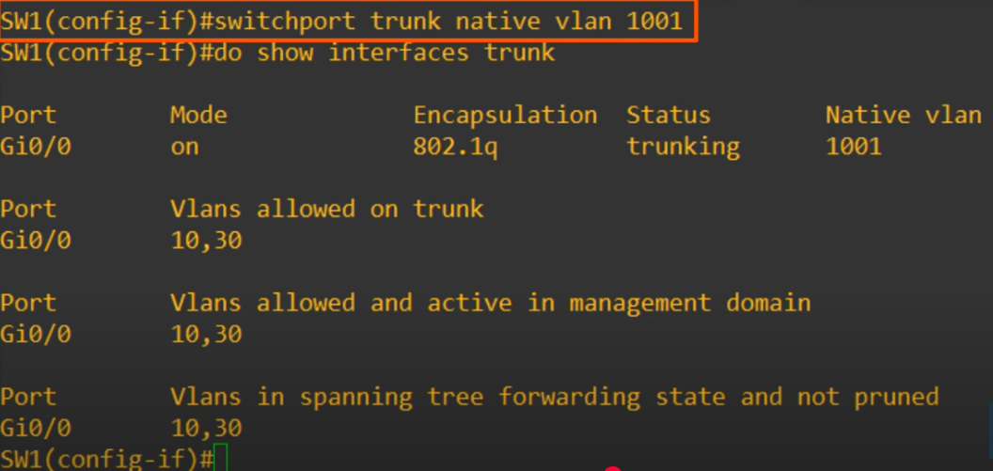

## **ROUTER ON A STICK (ROAS)**

### **What Is ROAS?**

* ROAS allows you to route between multiple VLANs using a **single physical interface** on a router.
* Router uses **sub-interfaces** for each VLAN.

#### **Key Points:**

* Sub-interface names follow the format: <interface_name>.<VLAN_ID> (e.g., G0/0.10).
* Each sub-interface:
  + Is assigned an **IP address**.
  + Is configured with a **VLAN tag** for its VLAN.

#### **Diagram of ROAS Example:**

### **ROAS Configuration Steps:**

1. On the **Router**:

Create a sub-interface for each VLAN:

interface G0/0.10

encapsulation dot1q 10

ip address <IP_Address> <Subnet_Mask> (last usable ip address of each subnet)

1. On the **Switch**:

Configure the interface connected to the router as a **trunk port**:  
switchport trunk encapsulation dot1q

* + switchport mode trunk

### **Verifying ROAS Configuration:**

1. Check sub-interfaces with:  
   show ip interface brief
2. View the routing table:  
   show ip route